SIMATS ENGINEERING (SAVEETHA SCHOOL OF ENGINEERING) Department of Computer Science and Engineering
ASSESSMENT TOOL 2 – SCENARIO BASED ASSESSMENT
Course Code: | CSA06 | Course Title: | Design and Analysis of Algorithms
CO Assessed: | CO2 – Manipulation (BL1, BL2, BL3) | Assessment: | Assessment Tool 2 – Scenario Based Assessment
Weightage: | 20% of CIA | Total Marks: | 100
CO2 Statement: | Apply Brute Force technique to solve sorting, searching, Closest-Pair and Convex-Hull problems (BL1, BL2, BL3)
Student Name: | G LOKESH YADAV | Reg. No.: | 192411061
Section / Batch: | CSE-2024 | Date: | 28-7-2026

Instructions to Students
• Answer the following question. Total Marks: 100.
• Carefully analyze the given scenario and identify the computational problem involved.
• Apply appropriate Brute Force techniques for sorting, searching, Closest-Pair, and Convex-Hull problems wherever applicable.
• Clearly justify the chosen solution approach with proper reasoning and analytical interpretation. • Demonstrate decision-making skills by comparing possible solutions and selecting the most suitable approach. • Use diagrams, stepwise illustrations, or algorithmic representations wherever necessary.
• Maintain clarity, logical organization, and proper technical presentation throughout the answers.

Question Type | Focus Area | Questions
Scenario Based  Assessment | Analyze real-world scenarios and apply Brute Force techniques for sorting, searching, Closest-Pair, and Convex-Hull problems | Q1

SECTION A – SCENARIO BASED ASSESSMENT

Q19. A database maintains sorted employee salary records, allowing Binary Search for quick retrieval. However, frequent updates disturb the sorted order.
a) Explain how Binary Search works when data is sorted.
b) Analyze its time complexity.
c) Discuss the importance of maintaining sorted data for efficient searching.
Code of Conduct
I G LOKESH YADAV -192411061 (Name / Reg No) certify that this submission is my original work and that I have adhered to the guidelines specified for this assessment. I understand that any violation of academic integrity rules will result in disciplinary action.
Signature of the Student: LOKESH YADAV

RUBRICS FOR CALCULATION
Criteria | Wt. | Level 4 – Exemplary | Level 3 –  Proficient | Level 2 –  Developing | Level 1 –  Beginning
Problem  Understanding & Context  Analysis | 25% | Thoroughly  understands the  scenario with accurate interpretation of all  requirements | Clearly  understands the scenario with  minor gaps | Basic  understanding; some aspects of the scenario  unclear | Poor  understanding or misinterpretation of the scenario
Application of  Concepts | 30% | Applies appropriate concepts effectively to solve complex real  world problems | Applies relevant concepts  correctly with  minor errors | Applies basic  concepts but  with limited  accuracy | Fails to apply  appropriate  concepts
Analytical &  Decision  Making Skills | 20% | Demonstrates strong analysis and selects optimal solutions with justification | Good analysis  with reasonable solutions | Limited  analysis;  solutions lack  justification | Poor or no  analysis; incorrect decisions
Solution Design & Approach | 15% | Well-structured,  innovative, and  feasible solution  approach | Logical and  structured  solution with  minor gaps | Basic solution  with limited  structure or  feasibility | Unclear or  incorrect solution approach
Clarity,  Justification & Presentation | 10% | Clear, well-justified explanation with strong reasoning | Clear explanation with some  justification | Limited clarity  and weak  justification | Poorly explained with no  justification

Marks Evaluation:
Criteria | Wt. | Level 4 –  Exemplary | Level 3 –  Proficient | Level 2 –  Developing | Level 1 –  Beginning
Problem Understanding & Context Analysis | 25%
Application of Concepts | 30%
Analytical & Decision-Making Skills | 20%
Solution Design & Approach | 15%
Clarity, Justification & Presentation | 10%
Total Marks (100):

Faculty In-charge | Course Coordinator | Head of Department
Name: | Name: | Name:
Signature: _______________ | Signature: _______________ | Signature: _______________
Date: ___________________ | Date: ___________________ | Date: ___________________

a) Explain how Binary Search works when data is sorted.
Explanation
Binary Search is an efficient searching algorithm that works only on sorted data. It repeatedly divides the search space into two equal halves until the required element is found.

Algorithm
Execution

Sorted Employee Salary Records



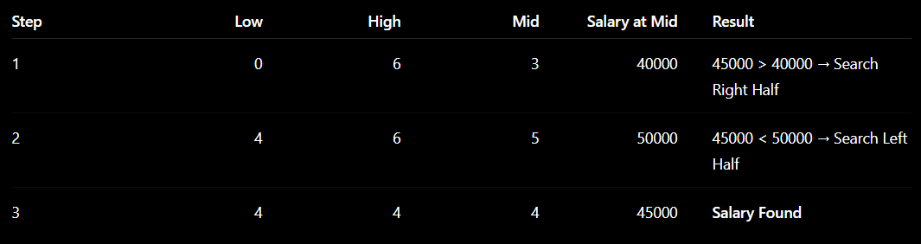
Explanation of Execution
Initially, the search starts from index 0 to 6. The middle element is 40000, which is less than the target salary 45000, so the algorithm searches only the right half.
Next, the middle element becomes 50000, which is greater than the target salary, so the algorithm searches the left half.
Finally, the middle element is 45000, which matches the target salary. Therefore, the employee salary is found successfully after 3 comparisons.

b) Analyze its Time Complexity.
Time Complexity Table
Case | Time Complexity
Best Case | O(1)
Average Case | O(log n)
Worst Case | O(log n)
Explanation
- Best Case – O(1): The target salary is found in the first comparison (middle element).
- Average Case – O(log n): The search space is divided into two equal halves at every step until the element is found.
- Worst Case – O(log n): The algorithm performs the maximum number of comparisons before finding the element or determining that it is not present.
Since Binary Search reduces the search space by half in every iteration, it is much faster than Linear Search for large datasets.

c) Discuss the importance of maintaining sorted data for efficient searching.
Explanation
Maintaining sorted data is essential because Binary Search works correctly only on sorted records.
If employee salary records are updated frequently by inserting or deleting values, the sorted order may be disturbed. In such cases, Binary Search cannot correctly divide the search space, resulting in incorrect or inefficient searching.
Therefore, the data should be sorted again after updates before applying Binary Search.
Importance
- Enables Binary Search to work correctly.
- Reduces search time from O(n) to O(log n).
- Improves database performance.
- Provides faster retrieval of employee salary records.
- Efficiently handles large datasets.

Result
Binary Search successfully finds the employee salary ₹45,000 in 3 comparisons. It has a time complexity of O(log n) and performs efficiently only when the employee salary records are maintained in sorted order.

